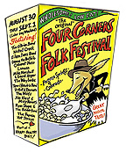  Darol Anger, Mike Marshall  With Rushad Eggleston  August 31, 2002  Late Night Summit Stage  - soundcheck workshop  - Shoot The Moon  - Down in the Willow Garden  - Big Man From Syracuse  - Swedish Fiddle Medley  - Jerusalem Ridge  - unknown title  - Melt the Tea Kettle  - Quigley  - Couscous | 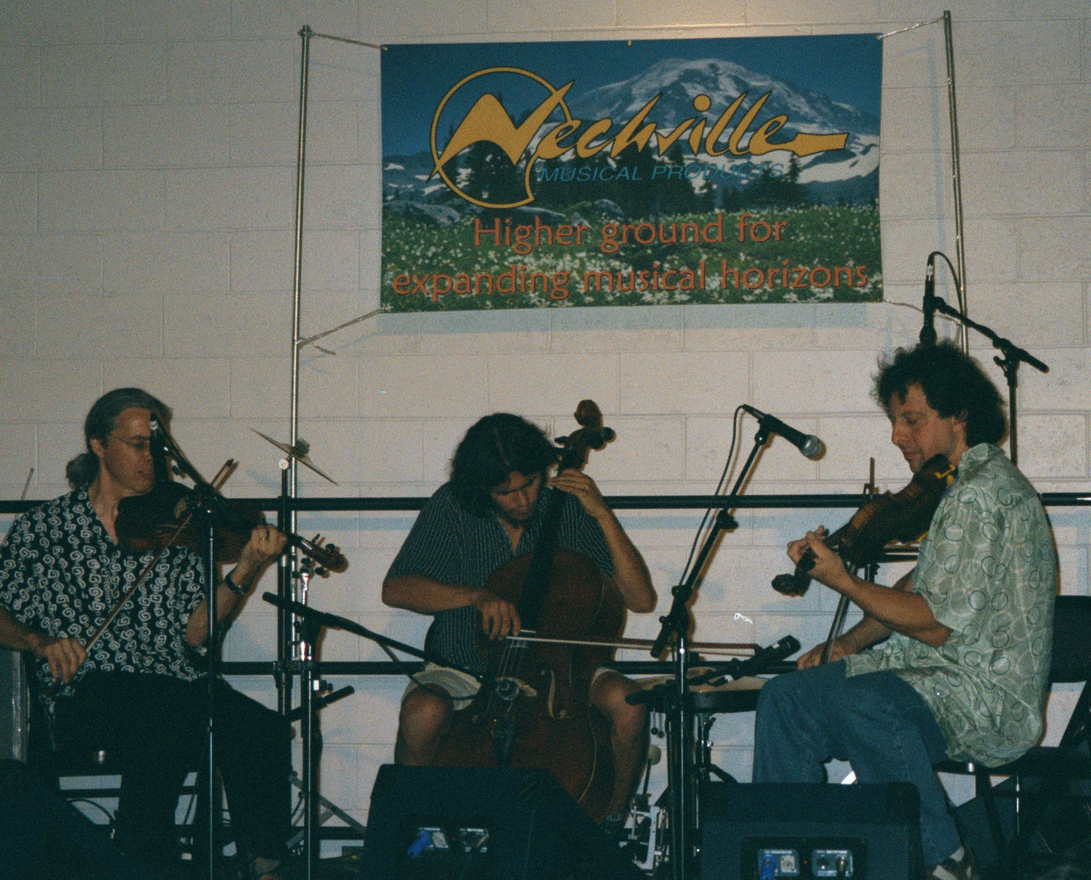  Darol Anger, Mike Marshall & Rushad Eggleston  August 31, 2002  Pagosa Springs, Colorado | Front Cover

Anger, Marshall & Eggleston 8-31-02 | Darol Anger, Mike Marshall & Rushad Eggleston  August 31, 2002 Late Night Summit Stage  - soundcheck workshop  - Shoot The Moon  - Down in the Willow Garden  - Big Man From Syracuse  - Swedish Fiddle Medley  - Jerusalem Ridge  - unknown title  - Melt the Tea Kettle  - Quigley  - Couscous  Source: Soundboard > Tascam DA-20 | Anger, Marshall & Eggleston 8-31-02

