Bluegrass for the Greenbelt
The Fifth Annual Benefit Concert for Greenbelt Alliance
Saturday, June 5, 2010  Dunsmuir Estate, Oakland  11 a.m. - 6 p.m.  Chris Hillman &  Herb Pedersen  Crooked Still  Laurie Lewis &  the Right Hands  The Wronglers  The Tuttle Family with A.J. Lee  Nell Robinson and Red Level  A.J. Downing & Buick6  Buy Tickets  $40 in advance; $45 at the door | 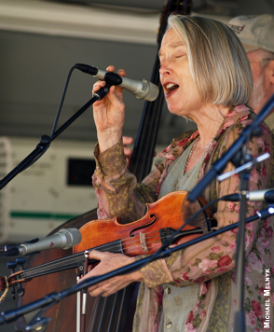

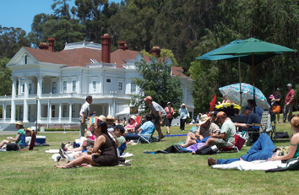 | 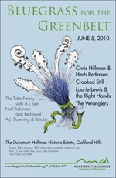
Kids 12 and under free; pony rides and more.
Bluegrass for the Greenbelt is generously underwritten by
The Hellman Family Foundation

